Project 3: ABAQUS Heat Transfer: Fin

Problem Statement: Evaluate the thermal performance of a fin subjected to temperature loading.

Geometry:
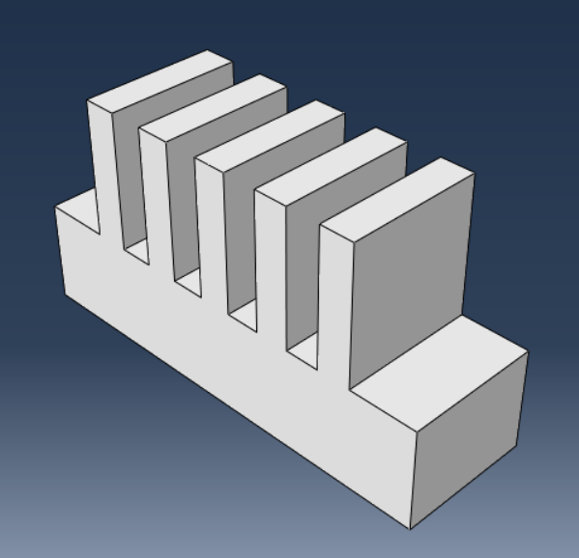

Material Properties:


Loading and boundary conditions:
- Temperature loading at the bottom surface,
- Body heat flux.

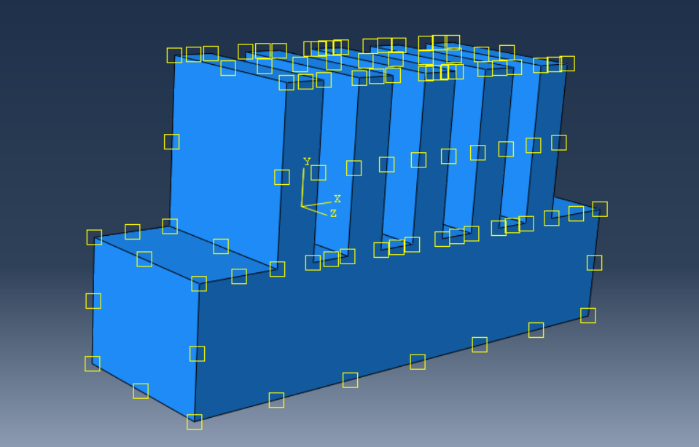
Mesh: (coarse due to limitation of 1000 nodes in ABAQUS educational version).

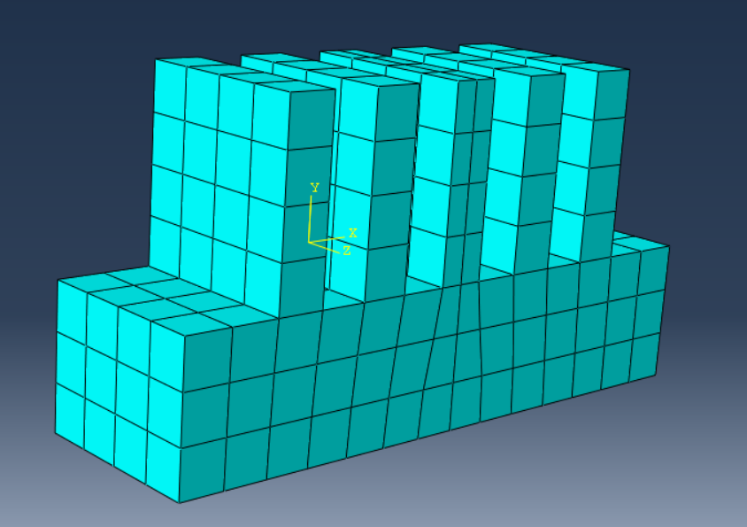

Results:
Nodal temperature:
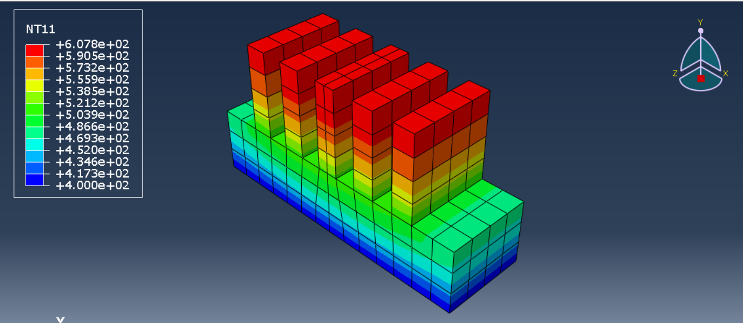

Heat flux per unit area:
